Identification of Victims Who Have Experienced Advanced Decay
Asan Petrus
Department of Forensic and Medicolegal Faculty of Medicine, University of Sumatera Utara, Medan
Correspondence: asanpetrus95@gmail.com
ABSTRACT
Background: In the process of investigating a criminal offense, knowing the identity of the victim is something that has a very important meaning, namely as an initial step of the investigation that must be made clear before the next steps can be taken in the investigation process. Objectives: to prove that the skeleton is a human skeleton, race, gender, estimated age, height. Case Illustration: Reported cases of a group of bones thought to have originated from human bones. Taken to the hospital to identify who the victim was. Discussion: Examination found a collection of 196 human bones, in the form of head, neck and the whole body remains bones as well as the right upper limb and lower limb still found skin and muscles that began to dry, blackish brown, foul smelling , a black cocoon (pupa) with a length of 3 cm, and a white maggot (instar I larvae) with a length of 0.5 cm.. Conclusion: Collection of bones derived from humans, with an estimated Mongoloid race (Asian), male sex, age 15-25 years, height 157-165 cm, duration of death 10-20 days, with signs of violence in the form of blood infiltration on the left head bone and right skull fracture that extends to the back. the cause of death of the victim is blunt trauma to the head that causes a skull fracture.

Keywords: Victim Identification, Further Decay

ABSTRAK
Latar Belakang: Dalam proses penyidikan suatu tindak pidana, mengetahui identitas korban merupakan sesuatu yang mempunyai arti yang sangat penting, yaitu sebagai langkah awal penyidikan yang harus diperjelas sebelum dapat dilakukan langkah-langkah selanjutnya dalam proses penyidikan. Tujuan: membuktikan bahwa kerangka tersebut adalah kerangka manusia, ras, jenis kelamin, perkiraan usia, tinggi badan. Ilustrasi Kasus: Melaporkan kasus sekelompok tulang yang diduga berasal dari tulang manusia. Dibawa ke rumah sakit untuk mengidentifikasi siapa korbannya. Pembahasan: Pemeriksaan ditemukan 196 kumpulan tulang manusia, berupa kepala, leher dan seluruh tubuh sisa tulang serta tungkai kanan atas dan tungkai bawah masih ditemukan kulit dan otot yang mulai mengering, berwarna coklat kehitaman, berbau busuk, berwarna hitam. kepompong (pupa) dengan panjang 3 cm, dan belatung putih (larva instar I) dengan panjang 0,5 cm. Kesimpulan: Kumpulan tulang yang berasal dari manusia, dengan perkiraan ras Mongoloid (Asia), jenis kelamin laki-laki, umur 15-25 tahun, tinggi badan 157-165 cm, lama kematian 10-20 hari, dengan tanda-tanda kekerasan berupa penyusupan darah pada tulang kepala kiri dan patah tulang tengkorak kanan yang memanjang ke belakang. penyebab kematian korban adalah trauma tumpul di kepala yang menyebabkan patah tulang tengkorak.

Kata Kunci: Identifikasi Korban, Pembusukan Lanjut

INTRODUCTION
In the process of investigating a crime, knowing the identity of the victim is something that has a very important meaning, namely as a first step in the investigation that must be made clear before further steps can be taken in the investigation process. If the identity of the victim cannot be known, then it is actually impossible to carry out an investigation. Furthermore, if the investigation does not find the identity of the victim, it is unavoidable that there will be errors in the judicial process which can have fatal consequences.^{[1,2]}
Identification is an attempt to re-identify unknown victims, either alive or dead, from those that are still intact and have not decomposed to the remaining tissue. Identification aims to determine a person's identity, especially for deaths involving criminal and civil cases.^{[3]}
The role of forensic medicine in identification is mainly on unknown bodies, bodies that have been damaged, decomposed, burned and mass accidents, natural disasters, riots that resulted in many deaths, as well as pieces of human bodies or skeletons. Of the nine known identification methods, only the method of determining identity with fingerprints (dactyloscopy), which is not usually done by doctors, but is carried out by the police. The other eight methods are: visual method, clothing, jewelry, document, medical, dental, serology and exclusion method. In forensic medicine, identification examination is known which is part of the task that has quite important meaning. It is stated that what is meant by identification is an attempt to find out the identity of a person through a number of characteristics that exist in an unknown person, in such a way that it can be determined that that person is the same as the missing person who was previously thought to be also known by those characteristics. That's all, identification has an important meaning both in terms of forensic and non-forensic purposes. How to identify if the corpse is dismembered or has become a skeleton? In this case identification is the doctor's job.^{[4,5]}

CASE ILLUSTRATION
We report a case of a collection of bones thought to have come from human bones. Taken to the hospital to identify who the victim was

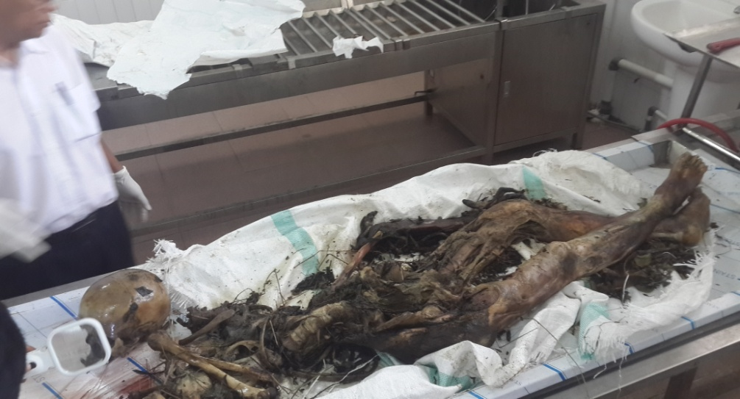
Figure 1. A collection of bones in a plastic jute bag

Found all the human bones found 196 pieces, in the form of head, neck and body only bones (Fig. 1) and upper right limbs and lower limbs visible skin and which began to move, blackish brown, foul smelling, found cocoons (pupa) black color with a length of 3 cm, and maggots (larvae instar I) white color with a length of 0.5 cm.
On examination for signs of death, the head, neck and entire body were left with bones and the upper right and lower limbs were still found have dry skin and muscles, blackish brown in color, and smelled bad.
Found one skull bone (os.cranium), yellow color, Found a fracture of the skull on the right back to the back of the skull (os.parietale – os. occipital) , with a blackish fracture edge with a length of 15 cm, 0.1 cm wide, with a distance of 6 cm from the bone tip of the right ear cavity (procesus mastoideus dextra), 9.5 cm from the bone tip of the left ear cavity / left mastoid process.
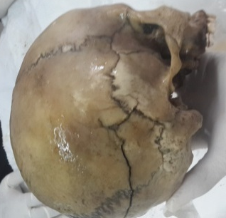

Figure 2. Fracture os. Parietal dan os. occipital

It was found that the meeting of the anterior skull bones (coronaria suture) had not yet fused, the middle skull bone meeting S3 (sutura sagitalis pars obelica) had begun to fuse (degree 1) (Fig. 2) and the junction of the posterior skull bones (sutura lamboidea) was found, not yet merged.
The largest length of the skull was found, measured from the connecting bones of the left and right forehead at the midline of the body at the base of the nose (glabela) to the back of the skull at the midline of the body (median-sagittal plane) 18.5 cm and the greatest width of the skull measured by distance. The outer wall of the temples is perpendicular to the midline of the body (median-sagittal plane) 15 cm, so that the cephalic index (head index) is 81.
Found the forehead bone (facies frontalis) erect. Found connecting the left and right forehead bones on the midline of the body where the bridge of the nose (glabela) protrudes. Found the eye brow bone (arcus super ciliaris) protruding. Found cheekbones (os zygomaticum) protruding. Found the eye socket (cavum orbita) rectangular. Found the nasal cavity (cavum nasi) with a length 3.5 cm, width 2.8 cm. Found the relationship of the forehead and nose bones on the midline of the body, angulations/angles are clear.
It was found that the length of the nasal bone was 1.8 cm. Found bony protrusion of the ear cavity (procesus mastoideus) left and right protruding. The roof of the mouth (palate) is U-shaped. Found the protuberance of the tailbone of the head (protubenrantia occipitalis externa) is not prominent. At the opening of the head cavity, no brain tissue was found. Lower jawbone: A narrow V-shaped lower arch (incisura mandible) is found. An opening in the lower jaw (foramen mentale) is found near the middle of the jawbone. It was found that the angle of the jaw (angulus mandible) was approximately 1200. There were no tooth fractures. There were 18 teeth that were incomplete and still attached to the upper and lower jaws, totaling 18 teeth.
On the upper jaw, the right and left M1 do not show any wear. M2 right and left do not show any wear. M3 right and left have not grown. In the lower jaw, the right and left M1 do not show any wear. M2 right and left do not show any wear. M3 right and left have not grown. The size of the first molar tooth diameter 1 cm.
The cervical spine contains 5 cervical vertebrae / os. Cervical fractures were not found. The back of the spine found 12 vertebrae in the back / os. Thoracalis. no fractures were found. The lumbar spine found 5 vertebrae in the lumbar spine, no fractures were found. Collarbone (os clavicula) found 2 collarbones (clavicula) left and right, no fractures were found. The shoulder blade (os scapula) found 2 shoulder blades / os scapula, no fractures were found. Found 3 breastbones (sternum) that are attached together, the length of the upper breastbone (manubrium sterni) is 5.8 cm, the length of the middle breastbone (corpus sterni) is 8.2 cm. Ribs (os costae) found 22 ribs (costae) left and right. No fractures were found. Pelvic bone found 2 pelvic bones (coxae) right and left. High shape, narrow and rough surface, outer surface of the pelvic bone (Crista Illiaca) S shape Clear. The preauricular sulcus is not clear (unnoticeable). The arch formed by the ventral cranial margin of the auricular fascia with the ventral cranial margin of the greater sciatica (arc.compose) 1 arch. The pelvic bone notch on the side (incisura ischiadica major) is narrow / sharp. The horns of the pelvic bone on the side (Spina Ischiadica) point medially. Found a hole in the side of the pelvic bone (foramen obturatorium), triangular in shape. The angle formed by a line drawn from the pubic bone (pubic bone) and the large Ischii (sitting bone). The right hip joint (acetabulum) was found, with a diameter of 4.4 cm and a depth of 2.7 cm. Found the angle of the pubic bone (angulus subpubicus) less than 90 °.
Found the pelvic inlet (superior pelvic aperture) rather wide and shaped like a heart (oval). A narrow pelvic inlet was found. Found a narrow pubic bone joint (symphysis pubis), no fractures were found.
The sacrumbone (os sacrum): Found 5 pieces of bone that are attached to 1, shaped like an isosceles triangle with a base width of 10 cm, right side length 13 cm, left side 13 cm long. The shape of the sitting bone (sacrum) is curved, there are no fractures. Tailbone (os coccygeus): Found 3 pieces of bone attached to 1. No fracture was found. Upper limbs: Found 2 upper arm bones (os. humerus) right and left, with a length of 28.5 cm each.
There were 2 right and left ulna bones, each measuring 24.5 cm long, 2 right and left os. radius bones were found with a length of 23 cm each. Found 8 (eight) wrist bones (os.carpalia) on the right. Found 5 bones of the right palm (os. Metacarpal). Found 14 finger bones (os. cross) right hand. Lower limbs: The lower limbs were found to have dry skin and muscles, blackish brown in color, foul smelling, advanced decay. Found 2 bones of the upper leg (femur) right and left, the length of the upper leg bone 41 cm. Found a large protrusion of the upper leg (trochanter major) protruding, Channel (trench) in the large protrusion of the upper leg (fossa trochanterica) deep, The line that runs from top to bottom of the upper leg (linea aspera) is prominent, The angle formed by the neck (collum femoris) and the body of the upper leg (corpus femoris) is blunt.
Found 2 kneecap bones (os.patella) right and left. Found 2 shin bones (tibia) right and left with a length of: 37 cm. Found 2 calf bones (fibula) right and left with a length of 35 cm, no fracture was found. He found the ankle bones, the bones of the soles of the feet and the right and left toes, still attached to each other, covered with muscles and skin that started to crumble, black in color and smelled bad. No fractures were found.
Samples were taken from several pieces of bone and teeth of the corpse to prepare for DNA and blood group examinations, when the time comes, someone will declare that they are the victim's family.

DISCUSSION
From the results of the post-mortem in the form of bones, the some questions regarding the bones can be explained as well as the conclusions of the examination results.
From the examination results, the bones are human bones seen from; the anatomical shape of the long bones, pelvic bones and other bones in terms of the anatomical shape of these bones is especially assessed on large bones such as the skull, macroscopically in accordance with the anatomical shape of human bones. Examination with the precipitin test can be done if macroscopically doubtful, for example if the bones found are only small pieces of bone that are not specific, such as the bone above.
The bones come from one individual, judging from the size of the bones, the number of bones, the color of the bones, the complexity of the bones, and the left and right of the bones. If it is difficult to determine macroscopically, then the examination that can be done to determine the number of individuals is by serological examination (blood type) and DNA examination for each existing piece of bone.^{[6]}
The sex of the victim based on the anatomical shape of the cranium, long bones and pelvis is male.
From various formulas it produces an estimate of height, in this case the author determines the height of the victim (156.92–164.52) cm according to the Trotter and Glesser formula because this formula is more suitable for Indonesians.^{[7]}
Estimated age of the victim is seen from the degree of suture obliteration, where obliteration of the S3 sagittal suture was complete/perfect at the age range of 20-29 years for males, while in this victim obliteration still occurred in the early S3 sagittal suture (degree 1), so I conclude that the age of the victim was 20-25 years. The fusion of the epiphyse with the diaphyse at the ends of the long bones of the os. The femurs appear to have been fully united, with an age range of more than 18 years. There are still 28 teeth (7 for each part) which means that the third molars (M3) have not yet grown, the age range is 12-14 years, while M3 grows at the age of 17-25 years, which means the current age range of the victim between 12-25 years. The degree of tooth wear, the first molars (M1) and the second molars (M2) were found to have zero degree of wear (no visible wear), while the third molars (M3) had not yet grown, so the victim's bones belonged to the age group 15-25 year.
From all the measuring tools for the estimated age of the corpse/bone above, I conclude that the estimated age of the victim is a young adult with an estimated age of 18-25 years.^{[8,9]}
Estimated duration of death is about 10 – 20 days, based on, the science of tanatology which mentions corpses that die 6-10 days. The soft tissues of the body soften and eventually become destroyed, the chest and abdominal cavities can be seen because some of the muscles have been destroyed and so on until finally only bones are left. Forensic entomology states, if there are cocoons that have hatched into adult flies, the time of death is approximately 11 days or more. Meanwhile, this victim found cocoons and larvae, which means that at this time the second fly cycle is taking place, meaning death between 11-22 days. Estimates based on odor, color and bone compactness, found that this collection of bones had a foul smell, yellow color and was still quite dense, so that it was included in the bone age group of less than 5 months. Bone age estimation based on Bernard's method (determination of nitrogen content, amino acids, benzidine reaction, fluorescence, immunology) was not carried out because this assessment is specific to bone age over 5 years to 800 years.
Determining the race from the bones assessment of the collection of bones from the Mongoloid race can be seen from^{[10]} the prominent anatomical shape of the zygomatic os, the cranium is square and Head index (cephalic index) 81 suitable for mongoloid race.^{[10]}
Signs of antemortem/postmortem violence on these bones found blood infiltration in the left skull and right skull fractures that extended to the back, where the edges of the fractures were darker in color than their surroundings, this indicates that trauma/fractures antemortem (occurs while the victim is still alive).
The cause of death of the victim was blunt trauma to the right side of the head which caused the skull bone to fracture.

CONCLUSION
Collection of bones derived from humans, with an estimated Mongoloid race (Asian), male sex, age 15-25 years, height 157-165 cm, duration of death 10-20 days, with signs of violence in the form of blood infiltration on the left head bone and right skull fracture that extends to the back. the cause of death of the victim is blunt trauma to the head that causes a skull fracture.

REFERENCES
- Amir A. Rangkaian ilmu kedokteran forensik edisi kedua. Medan. 2005. p. 69,70,179,202,203.
- Bernard CBE, Simpson,s Forensik Medicine 11th ed.New York: Arnold Publishers, 2010.
- Gani MH. Ilmu Kedokteran Forensic. Bagian Kedokteran Forensic FK Universitas Andalas. Padang. 2002. p. 65.
- Munim A. Penerapan Ilmu Kedokteran Forensik dalam Proses Penyidikan. Sagung Seto. 2016: 177
- Munim A. Pedoman Ilmu Kedokteran Forensik. Binarupa Aksara. 2009. p. 32.
- Hamdani N. Ilmu Kedokteran Kehakiman. Edisi Kedua. PT Gramedia Pustaka Utama. Jakarta. 2010. p. 83.
- Dahlan S. Ilmu Kedokteran Pedoman bagi Dokter dan Penegak Hukum. Edisi Pertama Cetakan III, Universitas Diponegoro. Semarang, 2004. p. 151-154.
- Budiyanto A, Widiatmaka W, Sudiono S, et al. Ilmu Kedokteran Forensik. Edisi pertama. Cetakan ke-2. Bagian Kedokteran Forensik Fakultas Kedokteran Universitas Indonesia. Jakarta, 2011. p. 199-201.
- Wahid SA. Patologi Forensik, Cetakan Pertama. Dewan bahasa dan Pustaka. Kuala Lumpur. 2012. p. 72-73.
- Glinka J. Antropometri dan Antroposkopi. 3rd ed. Fisip Unair Surabaya. 2019. p. 14-15

